**Wildfire Analysis and Prediction System**

Mehmet Kadri Gofralılar

Hasan Ali Özkan

**UI Snapshots:**

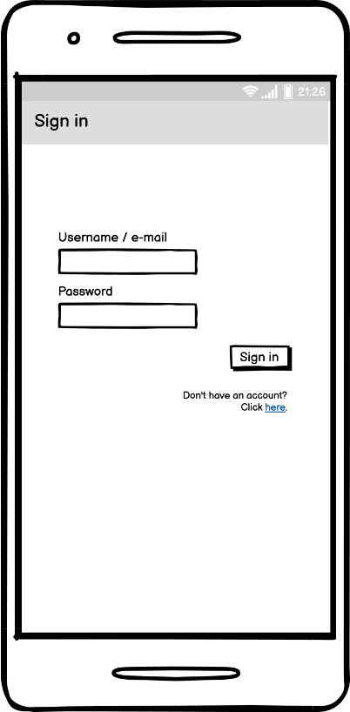

**Sign In Screen**

Users can sign into their accounts or if they don't have an account, they can go to the sign up page by using this screen.

**Sign Up Screen**

If users don't have an account, they can create an account in this screen. Also they can check the guide for WAPS if they have a problem.

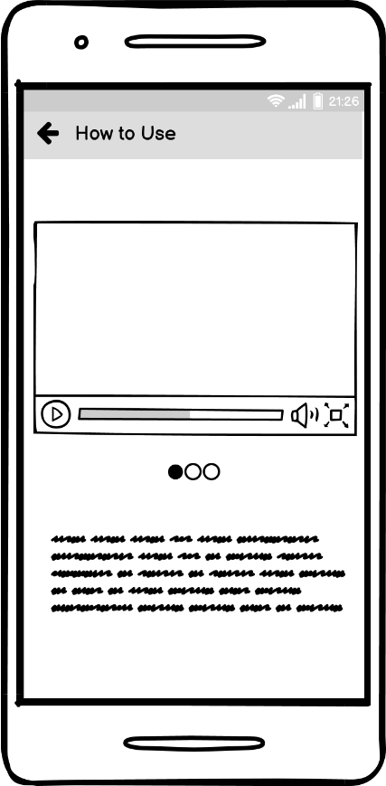

**Guide Screen**

Users can check the guide for WAPS if they have a problem or if they don't know how to use the app. There is a video and a couple of images to explain the usage.

**Main Menu Screen**

Users can view their notification histories and daily wildfires. When they see these, the items in list go dimmer. Also users can go to Settings screen from this screen.

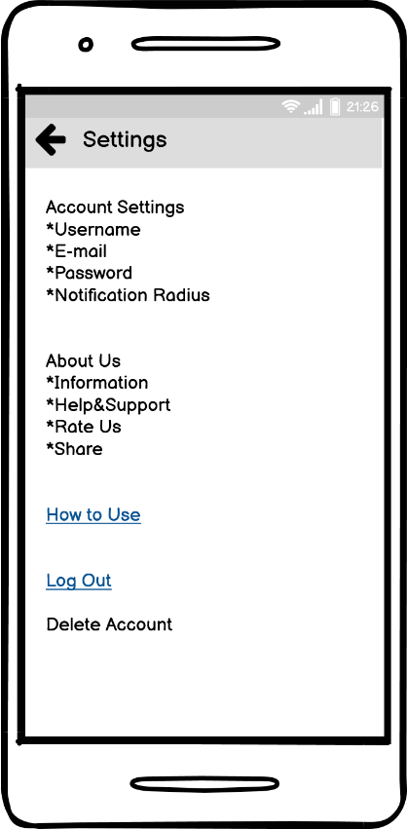

**Settings Screen**

Users can change their username, e-mail, password and notification radius. They can see information about us, get help, rate us, share the app and see other apps we made. Finally, they can go to the guide screen and log out.

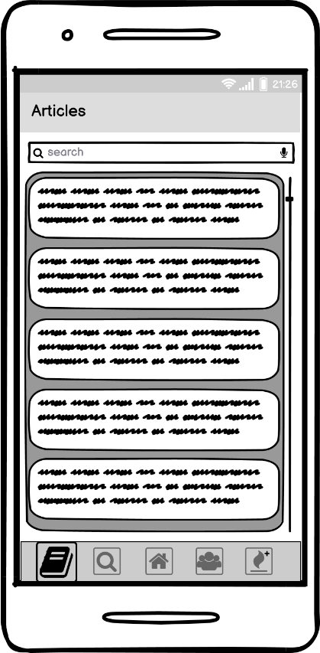

**Articles Screen**

Users can see the titles and authors' of various articles about wildfires and ways to protect wild life. They can check the articles by clicking on corresponding titles.

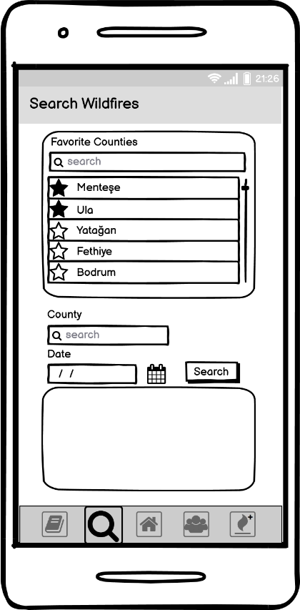

**Wildfire Search Screen**

Users can add their favorite counties to be notified. Also they can search for wildfires in a certain county on a specific date.

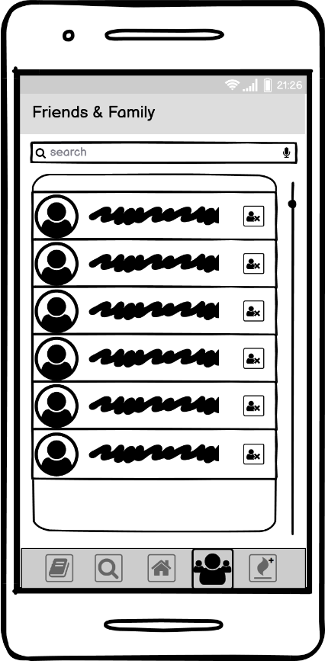

**Friends&Family Screen**

Users can add or discard their friends and family to see if there's a fire near them in this screen.

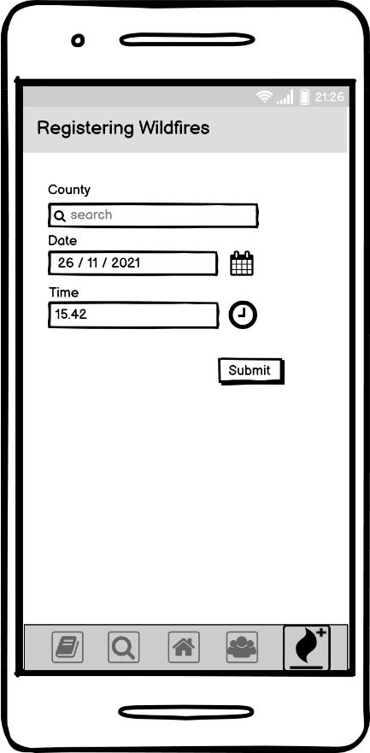

**Registering Wildfires Screen**

Users can register wildfires using this screen. After consideration, supervisors can add these to database.

**Wizard of Oz Video link:**

<https://youtu.be/iCHwgvTKff4>